Final Project

Frequency Modulator Demodulator design

EE460L (Spring 2019)

Objectives:

The main objectives of the project are to demonstrate operations of frequency modulator and demodulator. The carrier frequency is limited to 100 kHz. The Voltage-Controlled Oscillator(VCO) circuitry part of LM565 is used to generate FM waveform and the FM demodulator process is achieved by adding a second LM565 Phase-Locked-Loop(PLL) circuitry. Message signal is obtained from an iPod. In order to demonstrate the recovery process of the message signal a preamplifier, Sallen Key topology band pass filter ,25 watts audio amplifier and three speakers are introduced to the design.

FM Modulator

LM565 VCO

Audio Amplifier LM380

FM DemodulatorLM565 PLL

iPod

Message Signal

Audio Amplifier Board 25 Watts

Subwoofer 120W 8 ohms

Quad OP Amp Sallen Key Band Pass Filter

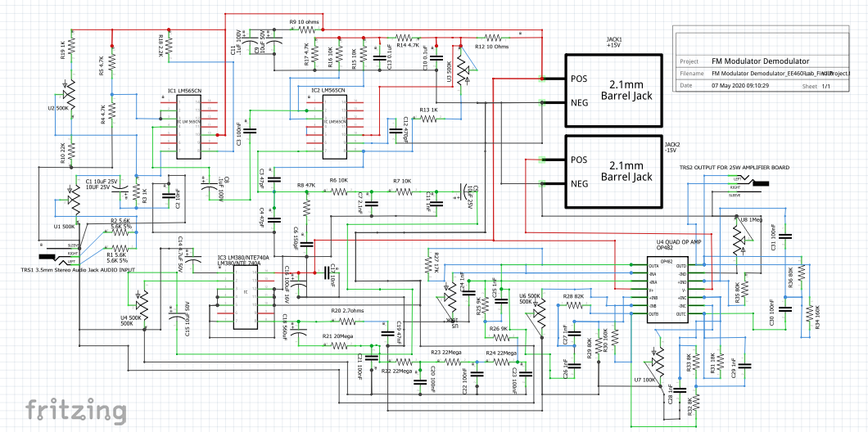

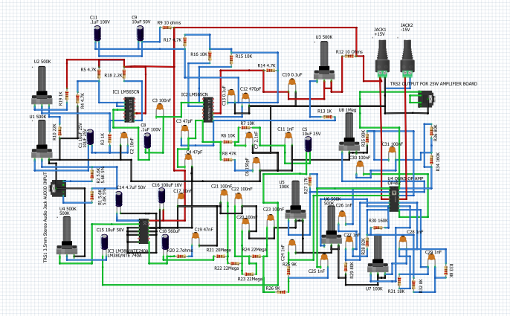

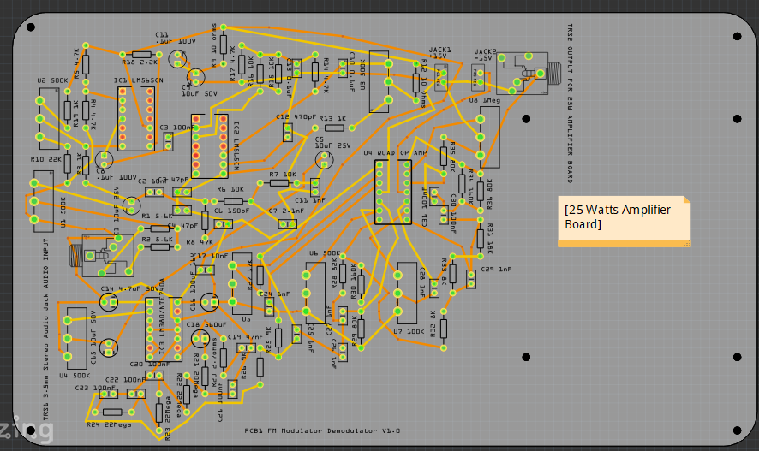

Future developments:

Transmitting and receiving circuits.

Voltage regulators +15V and -15V.